Findings Appsemble

SM42

Group 2

Finn Habraken

Niray Mak

Dary van Sleeuwen

Nidhi Sharma

Edgaras Spiridonovas

Gijs Zwegers

# Introduction

For our Smart Mobile course we (6 students from Fontys, mentioned in title page) were assigned to two clients.

Client 1: Olha Bondarenko from gemeente (township) Eindhoven wants us to create an application which helps the residents of Eindhoven. We were asked to do some research about problems and find one to solve.

Client 2: Kees van den Broek from d-centralize asked us to use Appsemble. Appsemble is low code platform to make applications. Appsemble is just released and still in its alpha. Kees asked us to use the platform, create code blocks and share our experience with it.

Our mentors at Fontys asked us to create the application for township Eindhoven using the Appsemble platform.

The project takes place between the 7th of May and the 2nd of July in 2020.

Due to the COVID-19 virus all students are working from home and they use Microsoft Teams to meet with each other, the clients and the mentors.

# Table of contents

# 

**Introduction** **2**

**Table of contents** **3**

**Setup** **4**

First impression YAML **5**

Impression while making a simple application. **5**

**Summary** **8**

**Conclusion** **9**

# Setup

After the advice of Appsemble collaborators we decided to run Appsemble on our local machines. According to them this was necessary to create new blocks.

It took a lot of time to install Docker which is required for Appsemble. I did not have the right Windows version. First I changed my Windows version in Regedit. But later I found out that caused issues. I found out we can get a free license for Windows Education at Surfspot which is compatible with Docker.

Appsemble setup itself was not easy to understand. The documentation wasn’t always correct. Later there was a video provided which made it a bit more clear. We are also in a Discord channel which helped us a lot. We had a very quick response on this channel after asking questions.

After like half a day of work of setting up Appsemble I finally managed to create an account and push the default templates and default blocks to the system.

# 

# First impression YAML

I never worked with YAML before so this was all new for me. The YAML file looked quite easy but after looking in to it a lot of this didn’t really make sense. It looks like a lot of stuff happens behind the scenes and I can not find out why it happens.

# Impression while making a simple application.

I tried creating a simple app. Wanted to add some buttons, tables etc. Just to find out how it works. I used the empty app template and wanted to add a new page with a table on it. I did this and tried to save the file. Unfortunately the YAML file was incorrect but I did not get any feedback what was incorrect about it. See picture underneath.

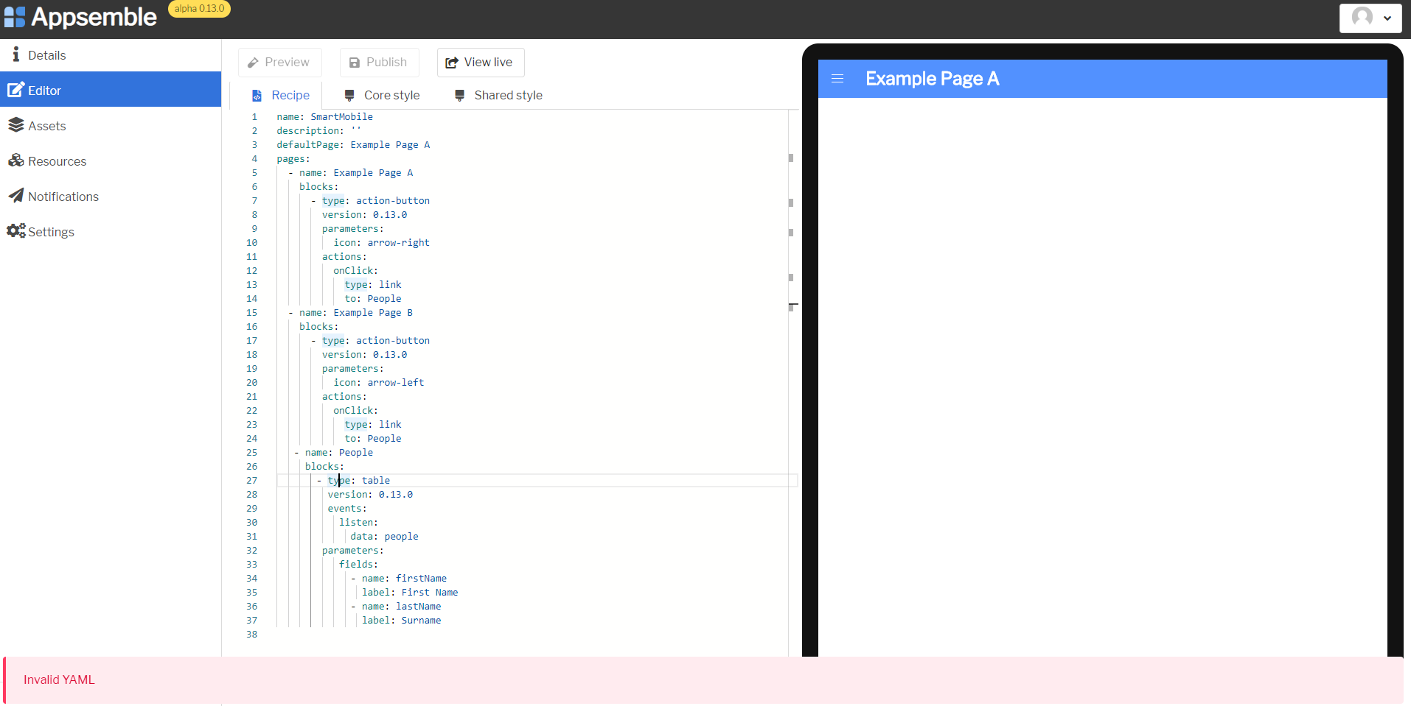

Also a few times I accidentally refreshed or clicked on another tab which made me lose all the changes I made.

After some time I managed to create a new page: page C. See picture underneath.

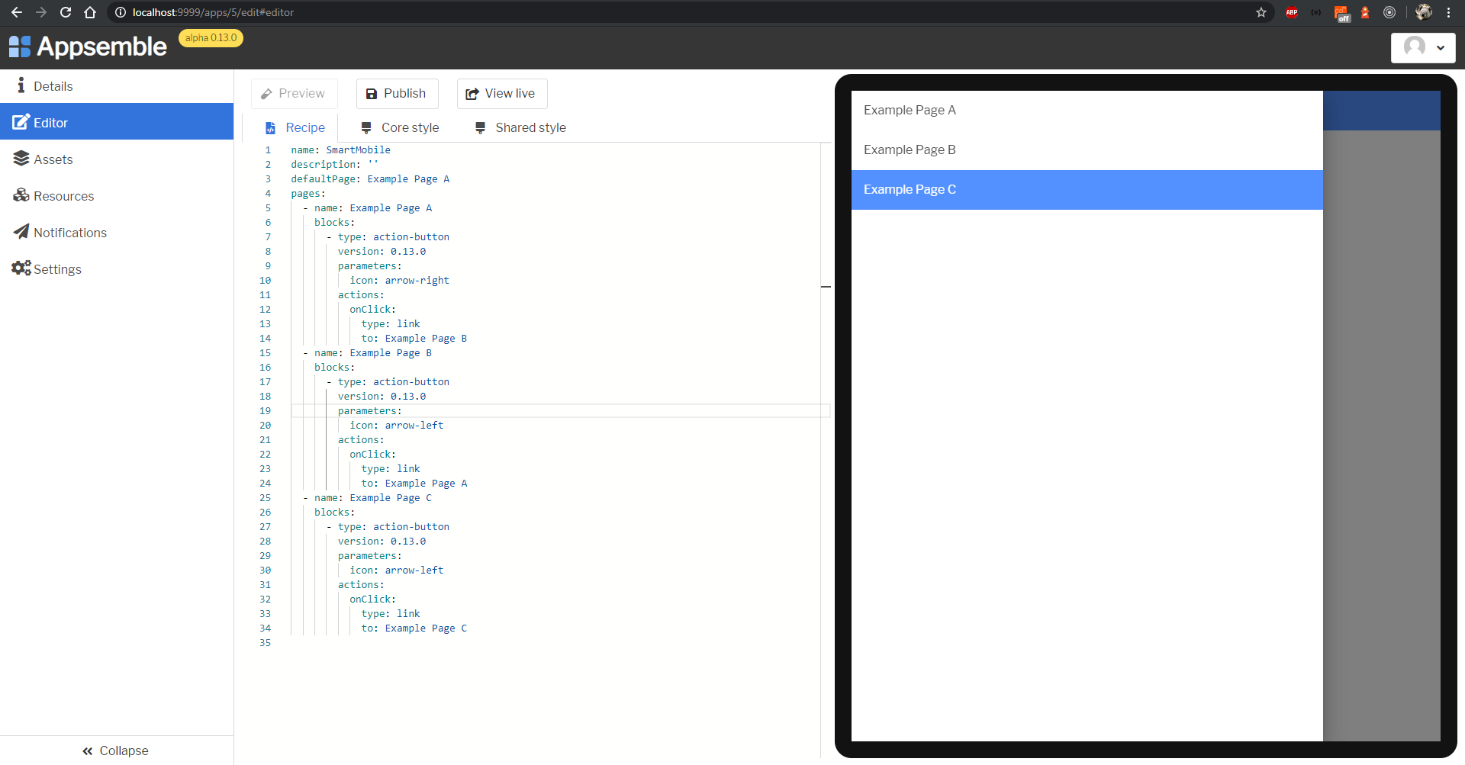

Then I tried to implement another simple thing, a button list. I found this buttons list at the Appsemble documentation. <https://appsemble.dev/blocks/button-list#introduction>

First of all, I was not sure what the type of this button list exactly was. After I checked the source code I found out it probably had to be button-list. So I tried that. First I tried without version. In the documentation provided by Appsemble I couldn’t find if it is required to define it. But after trying without I got an error message. Again no clear message. See screenshot underneath.



After adding the version the system didn’t give any feedback and it looked like the code compiled. I went to page: Example Page C, because that is where I defined the button-list, but only a loading icon showed up.

I tried to publish the code. Another message showed up. No clue what I’m doing wrong.



Later I concluded that the code underneath.. (which is example code)

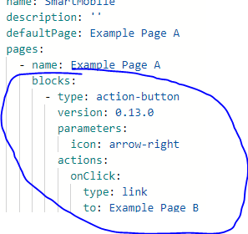

..was supposed to generate a action-button which looks like this: 

…but the page is empty.

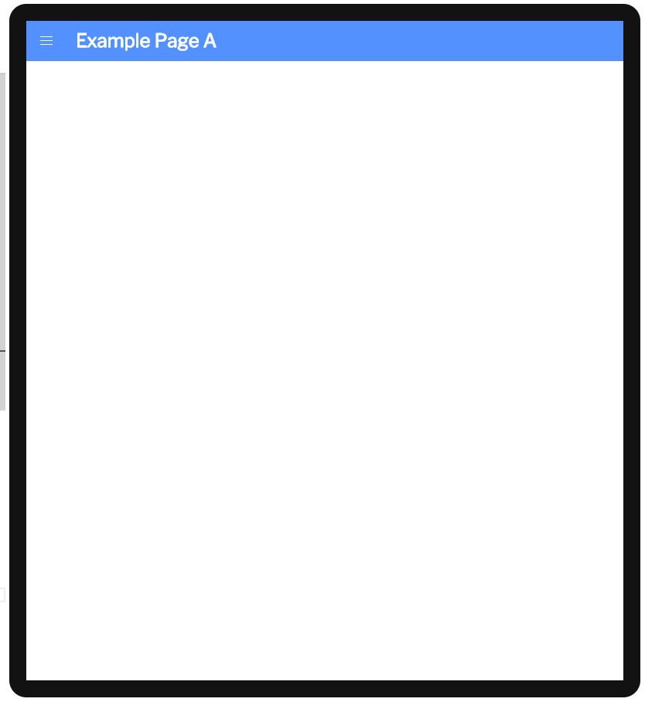

# Summary

# 

|  |  |
| --- | --- |
| **Problem** | **Solution** |
| Documentation was outdated sometimes | Support was great and fixed it immediatly after asking |
| UX for YAML editor. Error’s not always clear and no feedback in web IDE on what is incorrect. |  |
| Example blocks do not work |  |

# 

# Conclusion

We started working on the project and tried to make coding blocks with Appsemble with a lot of enthusiasm. The first thing we ran into was using docker, because a lot of people of our group didn’t have windows education or windows professional installed. This resulted into the first problem. After we found a fix for this and we could run the project.

During the installation a few of the commands that were provided by the documentation were not working. The support was great. After asking for help on the Discord channel usually we received response within 10 minutes. We managed to install Appsemble on our local machine.

After creating an account and pushing the blocks to the organisation we started experimenting around with YAML editor. Unfortunately the example page did not even work. We also tried to add some blocks with the editor but did not manage to get it working.

We spoke to our mentor about it and together we decided not to continue with Appsemble because it would probably take too much time to create an application within the timespan we have.

Altogether we do think Appsemble has a future. But there is still a lot of bugs to fix and UX to improve.